**GENERAL SIR JOHN KOTELAWALA DEFENCE UNIVERSITY**

Faculty of Management, Social Sciences and Humanities

Department of Languages

BSc in Applied Data Science Communication

INTAKE 40

Year 3: Semester 01

Continuous Assessment 1 -Sentiment Analysis with Reviews

Corpus analysis and data presentation

LB 3144

PDSS Pitiyage - D/ADC/23/0015

KH Wickramathunga - D/ADC/23/0039

**Content**

1. Introduction.
2. Background of the products
3. Reasons for selecting the products.
4. Describe the analysis tools.
5. Summary of Findings.
6. The overall sentiment score.
7. Conclusion
8. Real-world applications of sentiment analysis.
9. References.

**1.Introduction.**

Consumer impressions and purchase decisions are greatly influenced by customer reviews in the current digital economy. Businesses may learn a lot from these reviews about consumer satisfaction, usability, and product quality. A Natural Language Processing (NLP) method called sentiment analysis assists in categorizing these reviews into positive, neutral, or negative feelings. This allows businesses to track customer sentiment, see patterns, and make informed decisions.

The attitude of customer reviews for two products from the online marketplace Temu is examined in this study. To assess customer sentiment, thirty product reviews were gathered. Text analysis, sentiment categorization, and data preprocessing are all parts of the methodology. Charts and graphs are used to visualize the sentiment distribution and show what customers think.

The report also gives background information on the chosen products, emphasizing their attributes and marketability. The results show the distribution of sentiment, which aids in understanding product performance, customer happiness, and areas for development. This study emphasizes sentiment analysis's wider applications in boosting consumer interaction, product creation, and corporate strategy refinement. Businesses can improve their services, adjust to market demands, and bolster their market position by examining customer feedback.

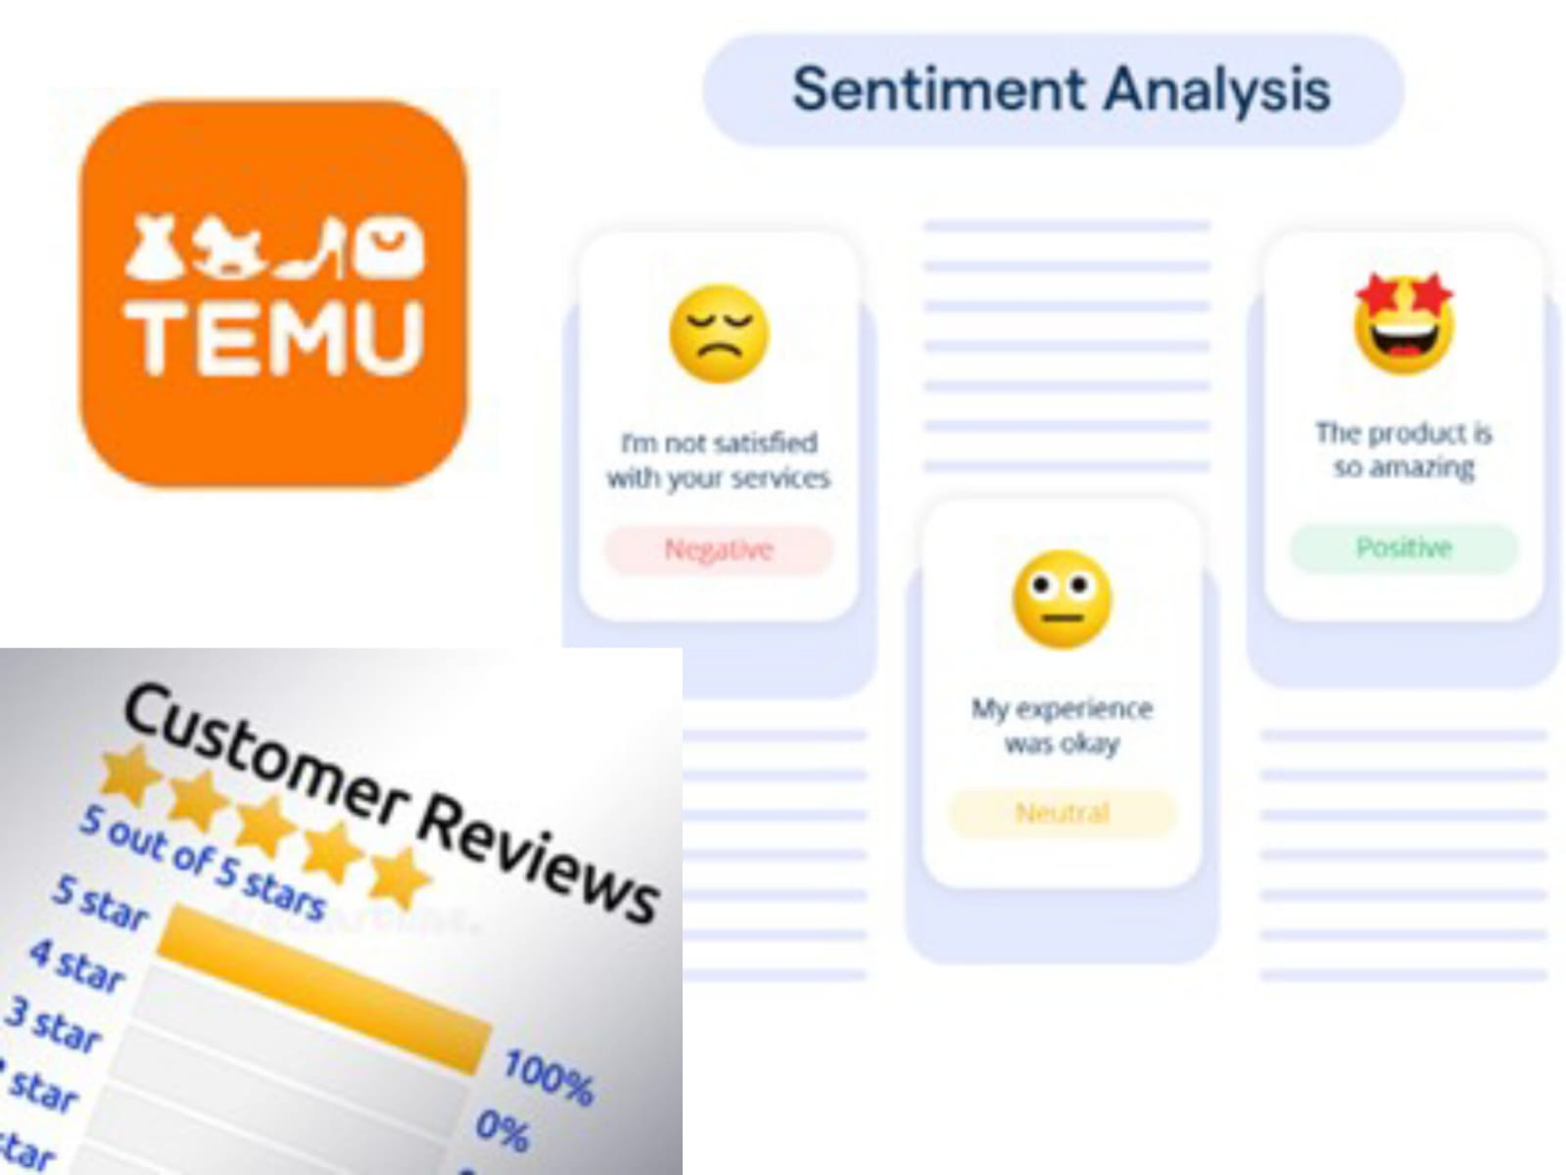

**2.Background of the products**

**( Product 01 )**

Mini Flower Decor Evening Bag, Elegant Rhinestone Clutch Bag, Women's Exquisite Dinner Bag For Party (19.99cm x 11.0cm x 4.5cm) For Carnaval

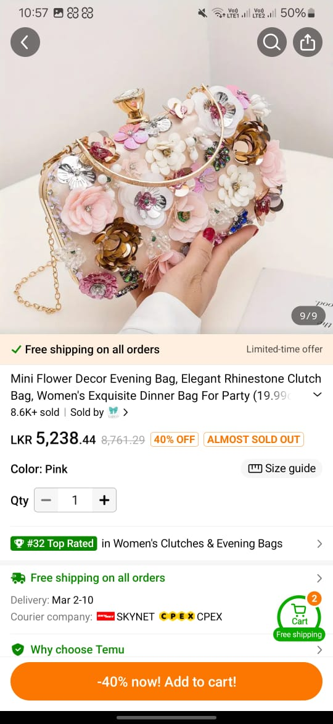 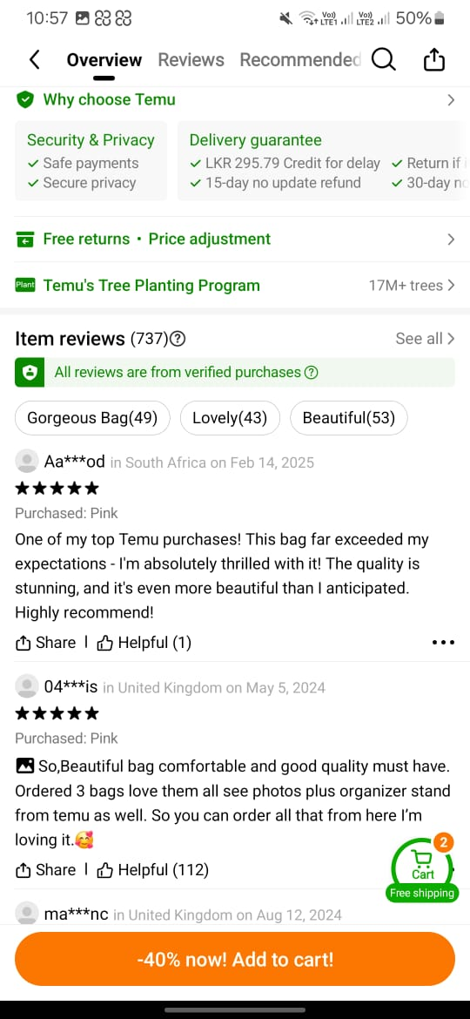

Designed for formal occasions like weddings and celebrations, the Mini Flower Decor Evening Bag is a chic and sophisticated accessory. It is made of premium polyester and has elaborate floral appliques and rhinestone accents that give it an opulent look. The kiss lock preserves the vintage look while guaranteeing security.

With its gold-tone chain strap, this pink clutch may be used as a shoulder bag or handbag for more versatility. Enough room is provided for necessities like a phone, keys, and cosmetics in the unlined inside.

Customers give the bag high marks for its exquisite craftsmanship, robustness, and distinctive style. For added convenience, Temu offers free shipping, returns, and a delivery guarantee. For those looking for a stylish, useful, and striking item to go with their evening wear, this bag is the perfect option.

Product link

<https://share.temu.com/Qk7LZsboFpA>

**( Product 02 )**

Fashion Golden 2 Pack Japanese and Korean Simple Style Small Earrings Plated with 14k Real Golden Mobius Style Party Dress Jewellery Easter Surprise Gift for Mom, Daughter, Friend Love Earrings

The Fashion Golden 2 Pack Japanese and Korean Style Earrings is a sophisticated and adaptable jewelry set made for lovers of contemporary fashion. These 14K gold-plated earrings are made of premium copper that has been nickel-free plated, guaranteeing their comfort and longevity. Their simplistic yet elegant design, which draws inspiration from mobius, makes them appropriate for everyday wear as well as trips.

These earrings offer a dependable and fashionable accessory choice thanks to their strong and secure fastening mechanism. Their golden polish adds to their opulent appeal, and their lightweight design guarantees comfortable long-term wear. Due to its excellent customer ratings and favorable evaluations, which highlight its elegance, timeless charm, and longevity, this product has become more and more well known. These earrings are a unique addition to any jewelry collection and are perfect as a present for loved ones or as a personal accessory. They effortlessly combine Korean and Japanese fashion inspirations.

Product link

<https://share.temu.com/N9UvvNkSTMA>

**3.Reasons for selecting the products**

Mini Flower Decor Evening Bag, Elegant Rhinestone Clutch Bag, Women's Exquisite Dinner Bag For Party (19.99cm x 11.0cm x 4.5cm) For Carnaval

* High Volume of Reviews and Consumer Interest

A rich dataset for sentiment analysis is provided by the bag's numerous user reviews. A greater number of reviews enables more precise trend and mood categorization.

* Style and Visual Appeal

It is an individualized product because of the flower appliques, rhinestone accents, and vintage style. Customers' preference for style above usefulness may be determined through sentiment analysis.

* Durability and Material

The bag, which is made of polyester and features elaborate graphics, can get mixed reviews for material quality and longevity. Future product enhancements might be guided by identifying typical compliments or grievances regarding workmanship.

* Usefulness and Practicality

Consumers' perceptions of the kiss-lock closing, usage, and storage capacity may differ. The bag's suitability for both space and adaptability may be evaluated through sentiment analysis.

* Variation in Color and Design

The bag's pink color may not be to everyone's taste.

Color-related opinions, such as whether buyers expected a different hue or thought it was excessively bright or drab, might be highlighted in reviews.

* Experience with E-Commerce

Reviews may contain comments on delivery, packaging, and return policies because the bag is offered on Temu with free shipping and returns. Examining comments pertaining to logistics might reveal information about the whole purchasing process.

* Adaptability to Various Situations

Consumers may provide their thoughts on whether the bag is appropriate for informal gatherings, parties, or weddings.

Sentiment analysis may show how actual usage and satisfaction match purchasing intent.

Fashion Golden 2 Pack Japanese and Korean Simple Style Small Earrings Plated with 14k Real Golden Mobius Style Party Dress Jewellery Easter Surprise Gift for Mom, Daughter, Friend Love Earrings

* Numerous customer reviews

Numerous evaluations of the product have been posted on several sites, offering a wealth of data for sentiment analysis. Numerous evaluations aid in spotting trends and patterns in consumer sentiment.

* Various Views on Consumers

Customers from a variety of age groups and fashion tastes are drawn to the earrings.

A thorough examination of positive, neutral, and negative thoughts is made possible by this diversity.

* Features of the Product That Impact Emotion

Customer satisfaction is directly impacted by features like 14K gold plating, cost, comfort, durability, and design. The characteristics that influence favorable or negative feedback can be identified using sentiment analysis.

* The impact of fashion and aesthetic trends

Trends, quality, and individual style all have an impact on jewellery tastes, which are often subjective. This offers a chance to examine how changing fashion trends influence consumer perception.

* Possibility of Market Knowledge

Businesses may enhance their product designs and marketing tactics by using the data to better understand client expectations.

Future product enhancements can be guided by identifying common complaints (e.g., size, material quality, or tarnishing).

* Relevance of Social Media to E-Commerce

Discussions about fashion accessories are common on e-commerce sites and social media.

Sentiment research may reveal how consumers see and talk about the product on various platforms, which might affect their choice to buy.

**4.Describe the analysis tool**

**Text2Data**

Text2Data is a sophisticated text analytics platform that uses machine learning (ML) and natural language processing (NLP) to glean insights from unstructured text data, including product evaluations. Through the platform, users may examine sentiment, pinpoint important subjects, and spot new patterns in textual input. To improve customer experience, it helps organizations make data-driven decisions and offers real-time sentiment scores.

Customer reviews were categorized into three sentiment categories for this research using Text2Data: positive, negative, and neutral. It also offered emotional scores, which were useful in measuring levels of contentment. Text2Data easily interfaces with Excel and Power BI, enabling further reporting and visualization.

**Microsoft Excel**

Microsoft Excel is a popular spreadsheet program that facilitates automation, data analysis, computations, and visualization. It has built-in functions, formulae, and pivot tables, among other crucial features that help in effectively organizing and analyzing big datasets.

Before doing sentiment analysis, the review data was preprocessed and stored in Excel for this study. To ensure that the sentiment analysis was clear and well-structured, the tool made it easier to sort, filter, and arrange the data. Prior to incorporating the data into Power BI for sophisticated reporting, Excel also contributed to basic visualization.

**Power BI**

Microsoft created the business intelligence and data visualization product Power BI. With its help, users may turn unprocessed data into interactive dashboards, graphs, and charts that make insights simple to understand.

Power BI was utilized in this research to display the distribution of sentiment across reviews. Pie charts and bar charts were used to show the percentage of neutral, negative, and positive attitudes in an understandable and approachable way. Finding the general consumer perception of the examined products was made easier by this representation.

This analysis effectively categorized and showed client sentiment by integrating Text2Data, Microsoft Excel, and Power BI. With the aid of these technologies, feedback analysis might be done in an organized manner, revealing important patterns, problems, and advantages of the items under examination.

**5.Summary of Findings**

Mini Flower Decor Evening Bag, Elegant Rhinestone Clutch Bag, Women's Exquisite Dinner Bag For Party (19.99cm x 11.0cm x 4.5cm) For Carnaval

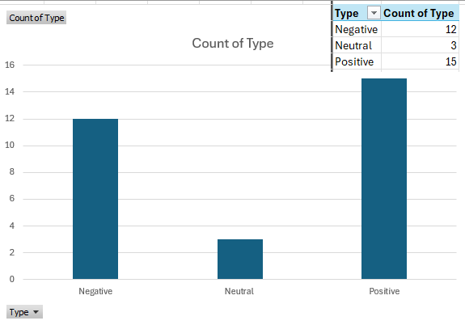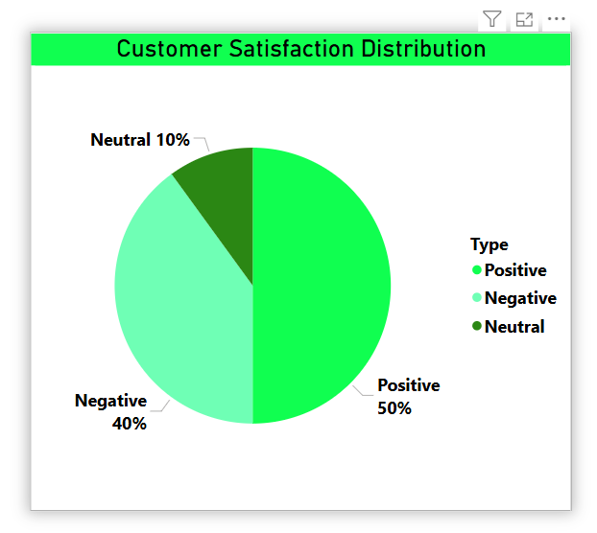

**Positive Sentiments (15 reviews):** The vast majority of evaluations are positive, suggesting that customers have a favorable opinion.

**Negative Sentiments (12 reviews):** A substantial portion of unfavorable evaluations express discontent or worries.

**Neutral Sentiments (3 reviews):** The majority of customers had strong opinions, as seen by the small number of impartial evaluations.

**Customer Satisfaction Distribution Analysis**

The pie chart shows how customer satisfaction levels are distributed according to the feedback that was gathered. Three categories are used to group the data:

* **Positive Feedback (50%)**: The vast majority of clients said they were happy with the service or product.
* **Negative Feedback (40%)**: A sizable percentage of consumers voiced discontent, highlighting areas that require improvement.
* **Neutral Feedback (10%)**: Customers who were neither satisfied nor unhappy made up a smaller portion of the population.

Although half of the customers are satisfied, this distribution shows that a significant 40% had bad experiences, indicating the need for more research into possible problems and areas that could be improved. Resolving client complaints may increase retention and general satisfaction.

The "Distribution of Review Counts by Score Range" bar chart shows how many reviews there are in each score range. With 11 reviews each, the 0.25 < Score ≤ 1 and -0.25 > Score ≤ -1 categories had the most reviews, suggesting a significant proportion of both good and negative comments. In contrast, there are fewer evaluations in the neutral or mild range for the -0.25 < Score ≤ 0.25 category, which has a lower count of 8. With more consumers expressing either great happiness or discontent than neutral input, this distribution shows a predisposition toward polarized viewpoints.

Fashion Golden 2 Pack Japanese and Korean Simple Style Small Earrings Plated with 14k Real Golden Mobius Style Party Dress Jewellery Easter Surprise Gift for Mom, Daughter, Friend Love Earrings

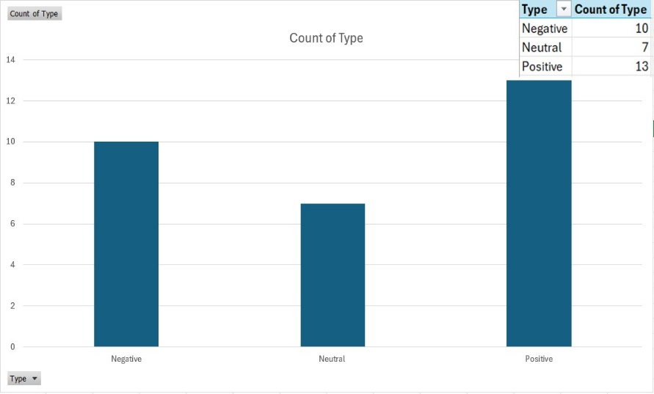

**Positive Sentiments (13 reviews):** The vast majority of reviews are favorable, indicating that customers generally have a positive opinion of the business.  
**Negative Sentiments (10 reviews):** A sizable percentage of reviews are unsatisfactory, expressing worries or bad experiences.  
**Neutral Sentiments (7 reviews):** The fact that there are fewer impartial reviews indicates that most customers have strong opinions, whether they are favorable or unfavorable.

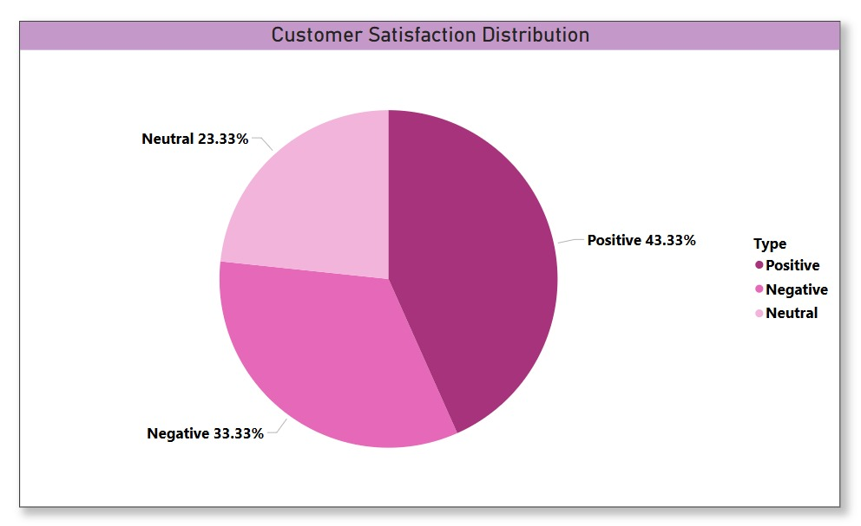

**Customer Satisfaction Distribution Analysis**

The pie chart shows how customer satisfaction levels are distributed according to the feedback that was gathered. Three categories are used to group the data:

* **Positive Feedback (43.33%):** Customers were generally satisfied with the goods or service.
* **Negative Feedback (33.33%):** A sizable percentage of clients voiced discontent, pointing to areas in need of development.
* **Neutral Feedback (23.33%):** Customers who were neither satisfied nor unhappy made up a smaller portion of the population.

This distribution shows that although 43.33% of consumers are happy, a sizable 33.33% had unfavorable experiences, indicating the need for more research into possible problems and areas that could use improvement. Resolving client complaints may increase retention and general satisfaction.

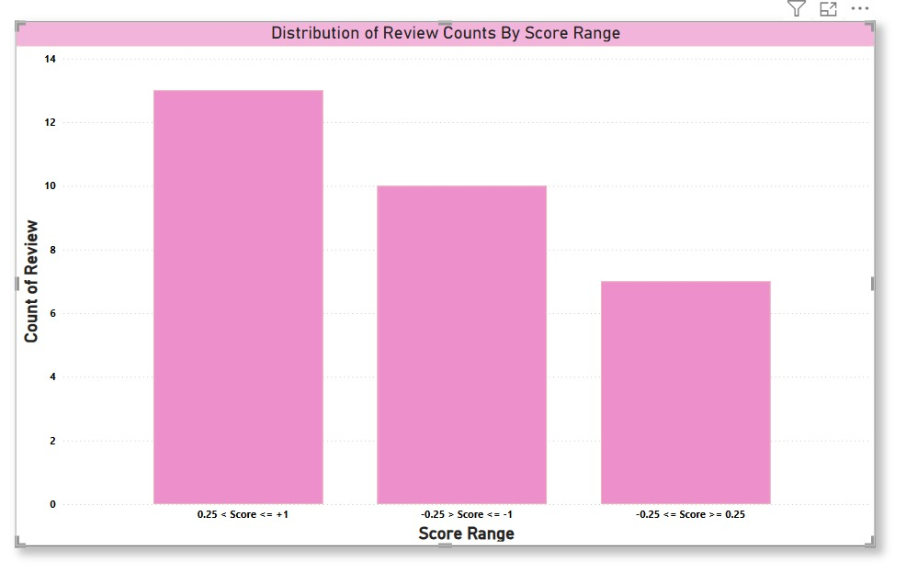

The distribution of review counts across three score ranges is seen in the bar chart. About 13 reviews fall into the positive range (0.25 ≤ Score ≤ +1), which has the largest count. The very unfavorable category (-0.25 < Score ≤ -1) has about 10 reviews. With roughly seven reviews, the neutral range (-0.25 ≤ Score < 0.25), has the fewest reviews. This distribution shows a polarized tendency, with neutral evaluations being less common and reviewers leaving feedback more frequently when they have strong opinions, especially favorable ones.

**6.The overall sentiment score**

Mini Flower Decor Evening Bag, Elegant Rhinestone Clutch Bag, Women's Exquisite Dinner Bag For Party (19.99cm x 11.0cm x 4.5cm) For Carnaval

Customers' perceptions of this product are somewhat positive but not overly enthusiastic, as seen by its total sentiment score of 0.123, which is comparable to that of the earrings. Customers are sure to value the bag's exquisite rhinestone design, which makes it a chic addition to celebrations and other special events. Nonetheless, some buyers may have voiced issues with practicality, size, or material quality. Even if the feeling is somewhat positive, it implies that although many purchasers found it appealing, others might have had expectations that weren't fully fulfilled.

Fashion Golden 2 Pack Japanese and Korean Simple Style Small Earrings Plated with 14k Real Golden Mobius Style Party Dress Jewellery Easter Surprise Gift for Mom, Daughter, Friend Love Earrings

A largely neutral feeling with a small positive slant is indicated by the overall sentiment score of 0.11. This implies that even though consumers value the earrings' exquisite design, 14k gold plating, and versatility, there may also be reservations or conflicting opinions about them. Durability, size, or quality in comparison to expectations are possible problems. Consumers may find them fashionable and reasonably priced, but they aren't very noteworthy, which could result in a mix of small complaints and contentment.

**7. Conclusion**

This study emphasizes how sentiment analysis may be used to comprehend how customers see goods sold in online marketplaces. A variety of favorable, neutral, and negative attitudes were found in the customer evaluations for the Fashion Golden 2 Pack Japanese and Korean Simple Style Small Earrings and the Mini Flower Decor Evening Bag. A sizable percentage of the feedback was unfavorable, indicating areas for development in terms of quality, durability, and consumer expectations, even though the majority of the responses were good for both products. An efficient methodology for categorizing and displaying sentiment trends was made possible by the combination of Text2Data, Microsoft Excel, and Power BI. The results highlight how sentiment analysis may provide organizations with insightful information that helps them better marketing strategies, boost consumer satisfaction, and tweak their goods.

Sentiment analysis has several real-world uses outside of e-commerce, such as public opinion analysis, financial market forecasting, customer service optimization, and fake news detection. It is a vital tool for data-driven decision-making in a variety of industries due to its capacity to glean insightful information from textual data. For a more thorough understanding, this study could be improved in the future by examining customer sentiment across other e-commerce platforms, adding more sentiment analysis techniques, and evaluating a larger dataset.

**8.Real-world applications of sentiment analysis**

Sentiment analysis (SA) is a natural language processing (NLP) approach that is widely used in many different fields to decipher human feelings and viewpoints that are reflected in textual data. Sentiment analysis has several notable real-world applications, including the following:

* **Fake News Detection**:  
  Sentiment analysis is a crucial method for identifying internet misinformation and fake news. It assists in identifying false or damaging narratives by analyzing the tone and attitude of news stories, social media posts, or comments. Sentiment analysis can identify severe, exaggerated emotional content in fake news, leading to additional verification.
* **Customer Service and Business Intelligence**:  
  To automatically classify client complaints, feedback, or inquiries into positive, negative, or neutral categories, sentiment analysis is frequently employed in customer service. It assists companies in improving customer satisfaction, identifying reoccurring problems, and prioritizing answers. It also offers insightful information about consumer behavior, which helps businesses make wise decisions.
* **Financial Market Predictions**:  
  To determine public opinion and forecast stock market trends, analysts and investors employ sentiment analysis to examine news stories, social media posts, and financial data. Sentiment analysis offers insights into possible market movements, and the financial performance of a company or market can be impacted by both positive and negative sentiment.
* **E-Commerce and Consumer Insights**:  
  Sentiment analysis in e-commerce assists companies in monitoring consumer perceptions of goods, services, or brands via social media, online reviews, and feedback. By matching their products to consumer preferences, this study assists businesses in improving their product offerings, customizing marketing campaigns, and raising customer happiness.
* **Social Policy and Public Opinion Analysis**:  
  Sentiment analysis, which examines social media, news stories, blogs, and forums, is essential for determining public opinion on political issues, governmental policies, and social concerns. Sentiment data can be used by companies and governments to comprehend societal issues, measure public reaction, and make data-driven policy decisions.
* **Healthcare Applications**:  
  Sentiment analysis is used in the healthcare industry to examine patient comments from social media, reviews, and surveys to monitor mental health, gauge public opinion on healthcare policies and treatments, and comprehend patient happiness. By examining the feelings conveyed in patient communications, it can also spot early indicators of mental health problems and pinpoint areas where healthcare services need to be improved.

**9.References.**

* <https://share.temu.com/8G9EooT8VFA>
* <https://share.temu.com/N9UvvNkSTMA>
* <https://text2data.com/Demo>
* <https://getthematic.com/sentiment-analysis>
* <https://medium.com/@swayampatil7918/getting-started-with-sentiment-analysis-a-step-by-step-guide-1a16085688a7>